# Data: Route SBS-1K, December 2018

Route SBS-1K, December 2018:

**Raw Data:** Attached Excel: tripocc_SBS1K

This includes the data regarding the buses run in route SBS1K during the month Dec 2018.

This is real time data as recorded by BMTC. It includes the bus number, its trip number, the time at which the bus reaches all the bus stop, and the number of people who got on the bus(boarded) and got off the bus(alighted). Based on the number of people boarding and alighting, the number of people present in the bus or the bus occupancy is also given.

This data is a pre-processed data extracted from Electronic Ticketing Machine (ETM) data and Automatic Vehicle Location Data (AVL) combined.

A view of the sheet is given below

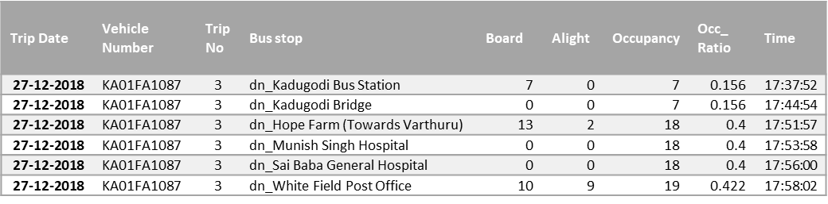

This data is considered raw data for all analysis done and was processed to a finer detail in the next excel.

**Processed Excel:** Attached Excel: Schedule_SBS1K_(23rd Sep)

Along with the previous real time data, which is now processed in this excel, it includes the data of how the bus trips were planned initially to run.

The sheet **Real time data** corresponds to the processedtripocc_SBS1K

1. Each row represents one bus stop reached by a bus, and then the number of boarding and alighting seen at that stop
2. Each bus is distinguished by its bus number and each trip undertaken by the trip number

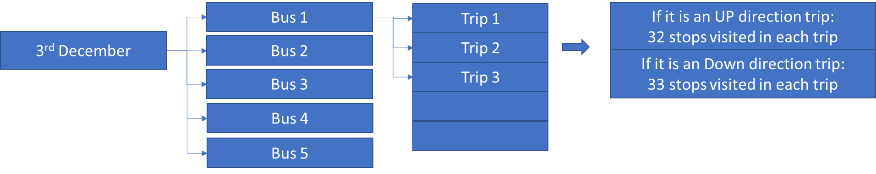

1. A bus capacity is seen as 60 people; 45 sitting and 15 standing; hence, another column is added **Occ/60** to check bus current occupancy percentage i.e. (occupancy/60)*100
2. A unique trip ID is created to each trip for easy calculation (Column E) ; includes, date, bus number, trip number and direction

The sheet **Depot wise shifts** tell about the buses planned to run from them.

Explanation: Depot 6

1. There are three types of service planned: Suburban day out; Suburban night out and Sub urban general service (type of service can be ignored for now)
2. Each schedule number in these corresponds to one bus.
3. Each bus may perform either 1 or 2 shifts in a day
4. In each shift, the bus performs several trips

The sheet **Scheduled Trips** tell about all the trips planned for all schedules

1. Each colour represents one schedule or bus
2. It gives start and end point of each trip and the time corresponding to it

The sheet **Error Check in trips** is to remove errors in real time data analysis. Approximately 20% data rows have error in them, hence these are to be excluded from calculation. This check is performed using following steps

1. The first and the last stop rows, of all trips are extracted from the **real time data** sheet
2. The total travel time in each trip is calculated by subtracting first stop time from last stop time
3. The following results are taken as error trips
   1. If the result is negative, there is error in time recording
   2. If Travel time less than 40 minutes, the travel time is too short
   3. If travel time higher than 4 hours with 0 boarding, then it is an empty trip
   4. If travel time higher than 4 hours and boarding greater than 1, then these are unusual or rare trips
   5. Some trips have conflict timings as 2 trips taking place at same day same time same bus

# Indicators

## Service Delivery

### Planned vs Actual Trips

The analysis is done in following steps

1. The start time of planned trips are extracted from **Scheduled Trips s**heet
2. Only full trips are used for analysis (i.e. only if start point and end point both are either Kadugodi Bus station or Shivajinagara Bus station)
3. The start time are counted based on the hour they start from, i.e. a histogram is created.
4. This gives us number of scheduled trips from in a particular hour
5. Actual trips start time are extracted from **Error check in trips** sheet
6. Similar to planned trips, histogram is created showing the number of buses starting in each hour
7. This compared to each other gives gap in number of trips planned v/s actual
8. The gap can be expressed in percentage difference

### Revenue hours per bus

The analysis is done in following steps

1. The travel time of all buses are extracted from **Error check in trips** sheet by using a pivot table
2. In pivot we keep ‘vehicle number’ as rows, and ‘trip date’ as columns with filter of ‘final observation’ using only ‘trips used for analysis’
3. Date filter removes data for weekends (Sat Sunday) and public holiday (25th December)
4. The values section includes sum of travel time
5. The average of all travel time may give us average revenue hours of all buses
6. The average of all sum travel time by one bus across different days is to be calculated in column. (Column W) i.e. Average revenue hour per bus per day

### Dispatch inconsistency

1. The trip start time of all buses are extracted from **Error check in trips** sheet by using a pivot table
2. In pivot we keep ‘trip date’ as rows, and ‘hour’ as columns with filter of ‘final observation’ using only ‘trips used for analysis & error travel time recording’ (as errors are in end time recording)
3. Date filter removes data for weekends (Sat Sunday) and public holiday (25th December); Direction filter gives observation of up and down trips separately
4. The values section includes count of vehicle number
5. The table in itself gives the bus dispatch inconsistency over the days

## Ridership

### Boarding per hour

1. This data is extracted using pivot from the sheet **Real time data**
2. In pivot we keep ‘time in hr’ as rows, and ‘trip date’ as columns
3. Date filter removes data for weekends (Sat Sunday) and public holiday (25th December);
4. The values section includes sum of boarding
5. An average of boarding is calculated in column for per hour (Column W)
6. Thus, the table gives the total and average boarding per hour
7. A direction filter may give observation of up and down trips separately

### Passengers moved per hour per direction (PPHPD)

Using the boarding per hour, and per direction from previous analysis, difference in passengers in morning hour and evening hour can be calculated

* Morning hour: 08:00 to 10:30 hours
* Evening Hour: 17:00 to 19:30 hours